|  |  |
| --- | --- |
| **2021 Year 12 ViSN Mathematics Specialist Unit 3**  **Test 3 – Vectors & Vector Calculus**  **Section One – Calculator Free** | |
| Mr Daniel Comtesse  Mandurah Catholic College | Calculator Free:______/20  Calculator Assumed:_____/31 |
| daniel.comtesse@cewa.edu.au | Result: _____/ ______% |

**Student Name:** ___________________________________________



**School:** ___________________________________________

**Time allowed:** Section One - 20 minutes

Section Two – 30 minutes

**Assessment Date: 2021**

**Material required/recommended**

***To be provided by the supervisor***

This Question/Answer Paper

SCSA Formula Sheet

***To be provided by the candidate***

Standard items: pens, pencils, pencil sharpener, eraser, correction fluid/tape, ruler, highlighters

**Submission Details**

Timed Assessments are to be returned to the ViSN teacher by the ViSN mentor (scan completed assessment and email to teacher above) within 24 hours of assessment date (above).

**Instructions to Students**

1. **ALL** questions should be attempted.

2. Write your answers in the spaces provided in this Question/Answer Booklet.

3. **SHOW ALL YOUR WORKING CLEARLY**. Your working should be sufficient detail to allow your answers to be checked readily and for marks to be awarded for reasoning. Correct answers given without supporting reasoning may not be allocated full marks. Incorrect answers given without supporting reasoning cannot be allocated any marks.

4. If you repeat an answer to any question, ensure that you cancel the answers you do not wish to have marked.

5. It is recommended that you **do not use pencil**, except in diagrams.

**Question 1 [4, 2 = 6 marks]**

A system of equations, where is a real constant, is as follows:



(a) Solve the system when .

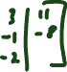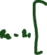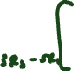

(b) Interpret the system of equations geometrically when .



**Question 2 [2, 4 = 6 marks]**

The equation of line is

(a) Show that the vector equation of the line is



(b) The diameter of sphere is the segment of line between and . Determine the equation of the sphere.

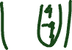

**Question 3 [5, 3 = 8 marks]**

Points and have position vectors and .

Note that , where is the angle between and .

(a) Determine and use the result to explain why and are collinear.

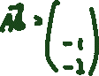

(b) Determine the Cartesian equation of the plane containing all four points.

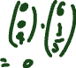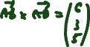

**End of Section One**



Extra working page

Question number: _________

|  |  |
| --- | --- |
| **2021 Year 12 ViSN Mathematics Specialist Unit 3**  **Test 3 – Vectors & Vector Calculus**  **Section Two – Calculator Assumed** | |
| Mr Daniel Comtesse  Mandurah Catholic College | Calculator Assumed:_____/ |
| daniel.comtesse@cewa.edu.au |  |

**Student Name:** ___________________________________________

**School:** ___________________________________________

**Time allowed:** Section One - minutes

Section Two – minutes

**Assessment Date: 2021**

**Material required/recommended**

***To be provided by the supervisor***

This Question/Answer Paper

SCSA Formula Sheet

***To be provided by the candidate***

Standard items: pens, pencils, pencil sharpener, eraser, correction fluid/tape, ruler, highlighters

Special items: scientific and/or CAS calculator, one A4 (one sided) page of notes.

**Submission Details**

Timed Assessments are to be returned to the ViSN teacher by the ViSN mentor (scan completed assessment and email to teacher above) within 24 hours of assessment date (above).

**Instructions to Students**

1. **ALL** questions should be attempted.

2. Write your answers in the spaces provided in this Question/Answer Booklet.

3. **SHOW ALL YOUR WORKING CLEARLY**. Your working should be sufficient detail to allow your answers to be checked readily and for marks to be awarded for reasoning. Correct answers given without supporting reasoning may not be allocated full marks. Incorrect answers given without supporting reasoning cannot be allocated any marks.

4. If you repeat an answer to any question, ensure that you cancel the answers you do not wish to have marked.

5. It is recommended that you **do not use pencil**, except in diagrams.

**Question 3 [3, 2 = 5 marks]**

Find the Cartesian equation of the following vector functions:







**Question 4 [3, 3, 2 = 8 marks]**

Drone and drone move with constant velocities and relative to the origin have initial positions and respectively, where distances are in metres.

One second later, the position of is and the position of is .

(a) Determine a position vector relative to the origin for each drone after seconds.

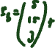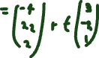

(b) Determine an expression for the distance between the two drones at any time .

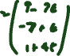

(c) Determine the minimum distance between the drones.



**Question 5 [2, 2, 2 = 6 marks]**

The path of a particle with position vector metres is shown below, where is the time in seconds and .

(a) Determine the initial velocity of the particle.



(b) Determine the velocity of the particle at the instant, , when it is moving parallel to the  
-axis.



1. Explain whether the particle will return to its initial position.



**Question 6 [3 marks]**

Plane has equation . Determine the Cartesian equation of .

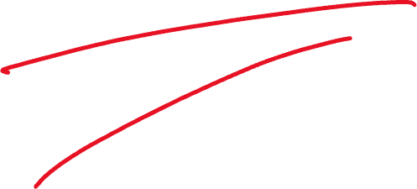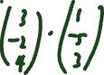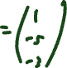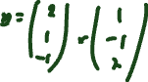

**Question 7 [2, 3, 4 = 9 marks]**

The position vectors of particles and (in centimetres) at time seconds, , are

and .

(a) Show that is moving with constant speed and determine this speed.



(b) Determine the Cartesian path of .



(c) Determine the position vector of the point where the paths of the particles cross and state whether a collision occurs.



**End of Assessment**



Extra working page



Question number: _________